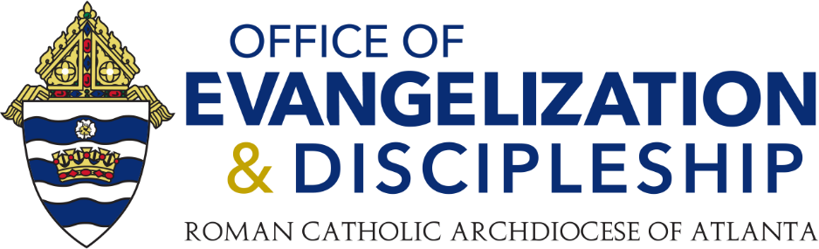

**PCL Call, May 9, 2023**

**Links Shared During Meeting**

**Rescue Atlanta (Sept. 9, 2023)**

Rescue Atlanta: <https://www.evangelizationatl.com/rescue>

Promo material for Rescue Atlanta: <https://drive.google.com/drive/folders/1u3jpryBMBOw4r-SxVgncm6laWm40qPSQ>

**Eucharistic Revival Parish Year**

FDLC has a guide for Eucharistic Processions: <https://fdlc.org/eucharistic-revival-resources/>

Eucharistic Revival Leader's Playbook for the Parish Year: [Parish Revival (eucharisticrevival.org)](https://www.eucharisticrevival.org/lead)

Eucharistic Revival resources for local Eucharistic processions, social media, etc: [Community Resources - Roman Catholic Archdiocese of Atlanta | Atlanta, GA (archatl.com)](https://archatl.com/revival/community-resources/)

**Special RCIA Presentation, FDLC Funded (May 23)**

Dr. Ximena DeBroeck Presentation, English: <https://rciaatlanta.org/event/reaching-for-the-gold-standard-in-rcia-with-ximena-debroeck/>

Dr. Ximena DeBroeck Presentation, Spanish: <https://rciaatlanta.org/es/event/presentacion-especial-de-la-subvencion-fdlc-sobre-rica-con-ximena-debroeck/>

**Virtual Conference on Gender and Sexual Identity (June 5-8)**

Gender & Sexual Identity Conference (virtual), June 5-8: [Gender & Sexual Identity 2023 | Ruah Woods Institute](https://www.ruahwoodsinstitute.org/gender-sexual-identity-2023/)

**Other Resources/Links**

Mental Health in Parish Ministry: <https://reviveparishes.com/>

OED Newsletter Sign Up: <https://mailchi.mp/archatl/signup-4-newsletter>